- In this assignment, I created two Java programs using basic OOP concepts.
In Question 1, I created a Student class with private variables, constructor, getters, setters, validation, and a method to display student information. I also created four student objects and displayed their information.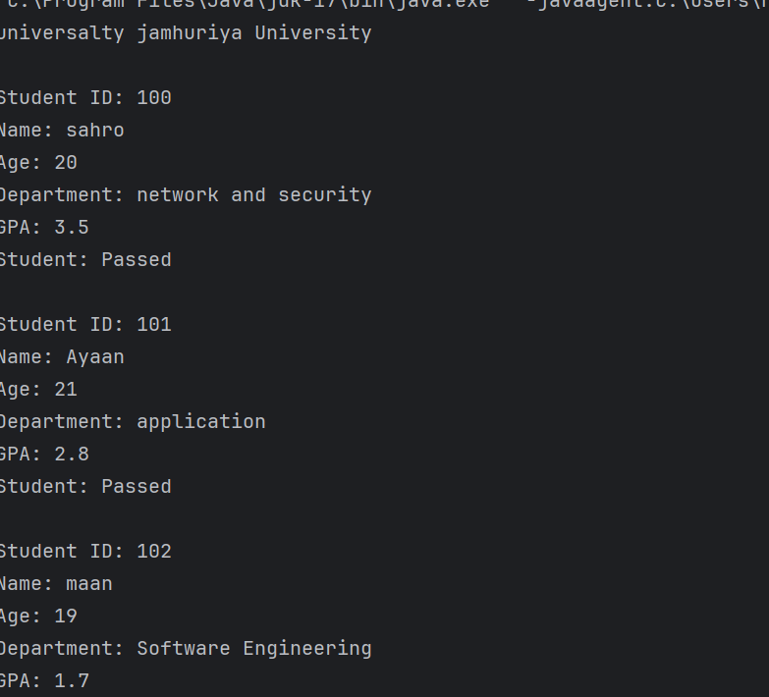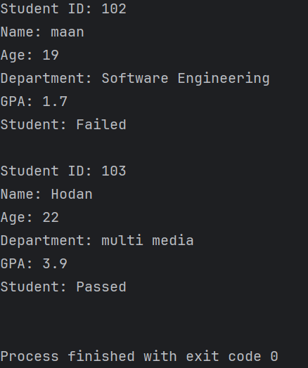In Question 2, I created a BankAccount class using encapsulation. I used private variables, getters, setters, and created two bank account objects. I also updated and displayed their balances.
- The programs were successfully executed, and the output is shown in the screenshots below.
- 